# Logical Data Modelling Design Use Case Part 1: Moon Launch Enterprise Study Case

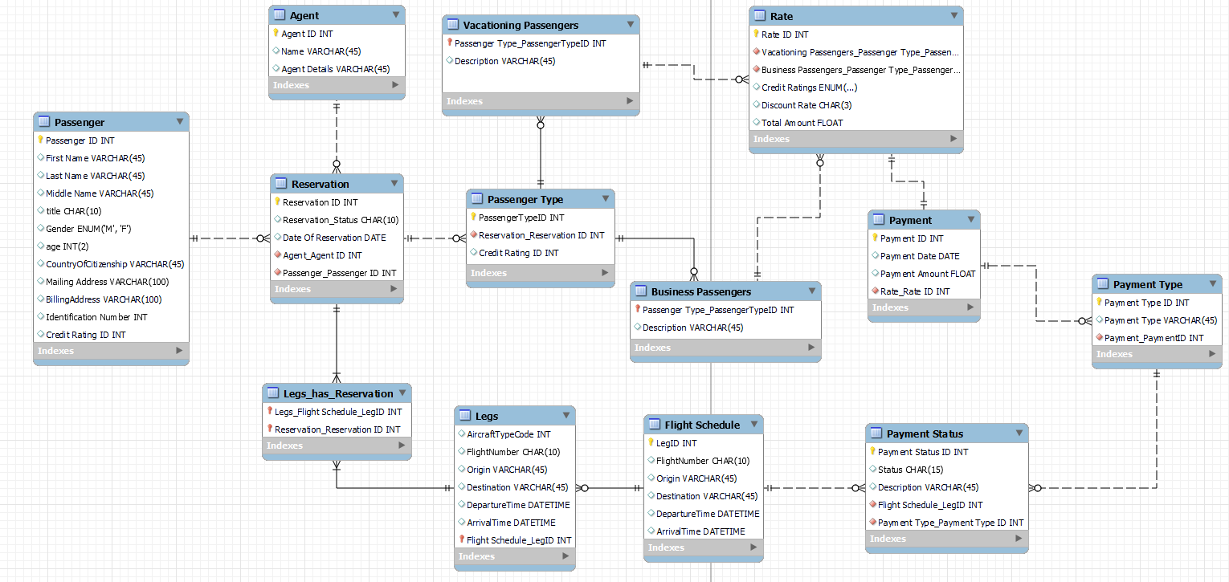

**Business logic/explanation/assumptions:**

1. Passenger – Contains all the data about passengers who have booked the flight tickets as well as those who booked and canceled the ticket
2. Reservation – Reservation data is stored about passengers booking and reservation details
3. Agent – Agent data and details are stored in this entity to facilitate work of agents and if anyone requires to find out about the agent who made the reservation
4. Passenger Type – This entity is for those passengers who have confirmed the reservation of their ticket and are classified into 2 categories : 1) Vacationing Passengers and 2) Business Passengers
5. Vacationing Passengers – Details of the Vacationing Passengers
6. Business Passengers – Details of the Business Passengers
7. Rate – This table is to properly compute ticket price. The table also tabulates credit ratings (A, B, C or D) of the passenger that is dependent on the credit history of the passenger who is travelling. The credit history information can be obtained with the passenger`s credit rating ID. The Rate entity also includes discount info obtained as well as the total amount that the passenger is ought to pay.
8. Payment – Data about the payment details that the passenger has made such as the date on which the passenger has paid, the amount the passenger has paid
9. Payment Type – Information of all the selected payment types/methods who is booking the reservation such as whether it is via cash, credit card, debit card or any other types of payment method modes such as World express card and etcetra.
10. Payment Status - This table shows the payment status to see if the payment has been approved or declined or any other details/information on the payment status
11. Legs- In this table is Leg_id, because Legs used in the airline industry help to describe a trip that keeps the same flight number and aircraft throughout its travel from one airport to the next.
12. flight_schedule: This table is mainly for the flight schedules, origin and destination and the departure time and arrival time. Since the case study mentioned that there were only four flights a day, two to the moon and two back, having this entity will be useful for recording the flight schedule information purpose.